HEART DISEASE RISK PREDICTION
Using IBM SPSS Statistics and Python
PROJECT-BASED LEARNING (PBL) REPORT
Subject:-
Predictive Modeling Using SPSS

Programme:-
B.Tech – Artificial Intelligence & Data Science

Institution:-
Sanjivani University

Submitted By:-
Yash Kaklij
Siddhika Kankubji
Sakshi Patvi

Academic Year
2026–2027

Abstract
This project demonstrates a data-analysis and classification workflow using the processed Cleveland subset of the Heart Disease dataset. IBM SPSS Statistics was used to import the data, define variable names, create a binary outcome from the original NUM field, inspect missing values, and calculate descriptive statistics. Python was used to train and evaluate Logistic Regression and Decision Tree classifiers. The dataset contains 303 records. In the recorded Python run, 227 records were used for training and 76 for testing. Logistic Regression achieved 85.5% accuracy and ROC-AUC of 0.937, while the Decision Tree achieved 73.7% accuracy and ROC-AUC of 0.830. The results show how two classification algorithms performed on this specific split. They do not establish clinical usefulness and must not be used to diagnose an individual.

1. Introduction
Data analytics and predictive modelling can help students understand how datasets are prepared, explored, and used in classification tasks. This project combines SPSS for data management and descriptive statistics with Python for machine-learning model development and evaluation. The dataset contains demographic, clinical-test, and exercise-related fields. The project focuses on predicting the dataset's recorded binary outcome rather than predicting future onset of heart disease.

2. Problem Definition
Problem statement: Prepare the processed Cleveland heart-disease dataset, explore its characteristics, and evaluate whether Logistic Regression and Decision Tree models can classify records into two groups based on the recorded outcome.

2.1 Objectives
- Import and understand the structure of the dataset in SPSS.
- Rename variables clearly and retain the original target variable NUM.
- Create a binary target variable called heart_disease.
- Inspect missing values and summarize numeric variables.
- Train Logistic Regression and Decision Tree classifiers in Python.
- Evaluate models using accuracy, precision, recall/sensitivity, specificity, F1-score, ROC-AUC, and confusion matrices.
- Interpret the results carefully and document limitations and ethical considerations.

3. Dataset Description
The project uses the processed Cleveland subset of the UCI Heart Disease dataset. It contains 303 records. The original file includes 14 columns: 13 predictor variables and the original target variable NUM. The variables describe age, sex code, chest-pain type, resting blood pressure, cholesterol, fasting blood sugar, resting ECG, maximum heart rate, exercise-induced angina, OLDPEAK, slope, CA, THAL, and the original outcome code.
Variable | Description | Role / measurement
AGE | Age in years | Predictor; scale
SEX | Source dataset sex code | Predictor; categorical
CP | Chest-pain type code | Predictor; categorical
TREST | Resting blood pressure | Predictor; scale
CHOL | Serum cholesterol value | Predictor; scale
FBS | Fasting blood sugar code | Predictor; categorical
RESTECG | Resting electrocardiographic code | Predictor; categorical
THALACH | Maximum heart rate achieved | Predictor; scale
EXANG | Exercise-induced angina code | Predictor; categorical
OLDPEAK | Exercise-induced ST depression | Predictor; scale
SLOPE | Slope code | Predictor; categorical
CA | Number of major vessels coded by fluoroscopy | Predictor; coded categorical
THAL | Thal code | Predictor; categorical
NUM | Original outcome code, 0–4 | Original target
heart_disease | Binary outcome derived from NUM | Binary target

3.1 Binary target definition
The original NUM variable has values from 0 to 4. For this project, NUM = 0 was mapped to heart_disease = 0, and NUM values 1 through 4 were mapped to heart_disease = 1. This groups all non-zero original outcome levels into one positive class and simplifies the task to binary classification. It also removes the distinctions between the original non-zero levels.

4. Data Import and Preparation in SPSS
- Imported the comma-separated processed Cleveland dataset into SPSS as 14 numeric columns and 303 records.
- Renamed the columns to meaningful variable names, including AGE, SEX, CP, TREST, CHOL, FBS, RESTECG, THALACH, EXANG, OLDPEAK, SLOPE, CA, THAL, and NUM.
- Used Transform → Recode into Different Variables to create a new variable called heart_disease, keeping NUM unchanged.
- Defined the old-to-new mapping as 0 → 0 and the range 1 through 4 → 1.
- Inspected the resulting Data View to confirm that the new variable contains binary values 0 and 1.
- Ran frequency tables and descriptive statistics to understand the dataset before modelling.
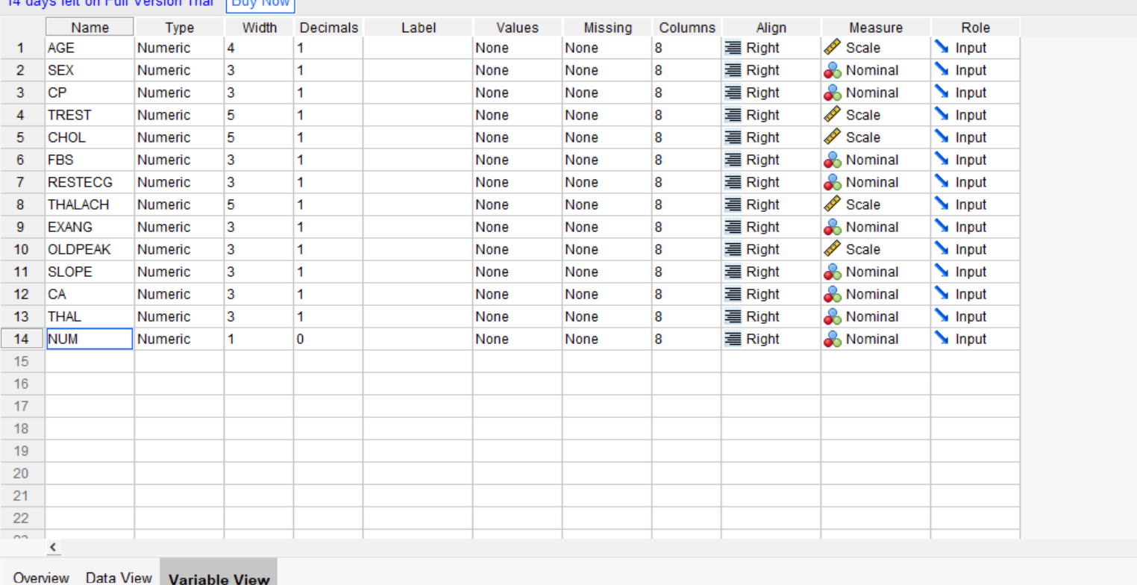
Figure 1. SPSS Variable View showing the renamed variables and measurement settings.
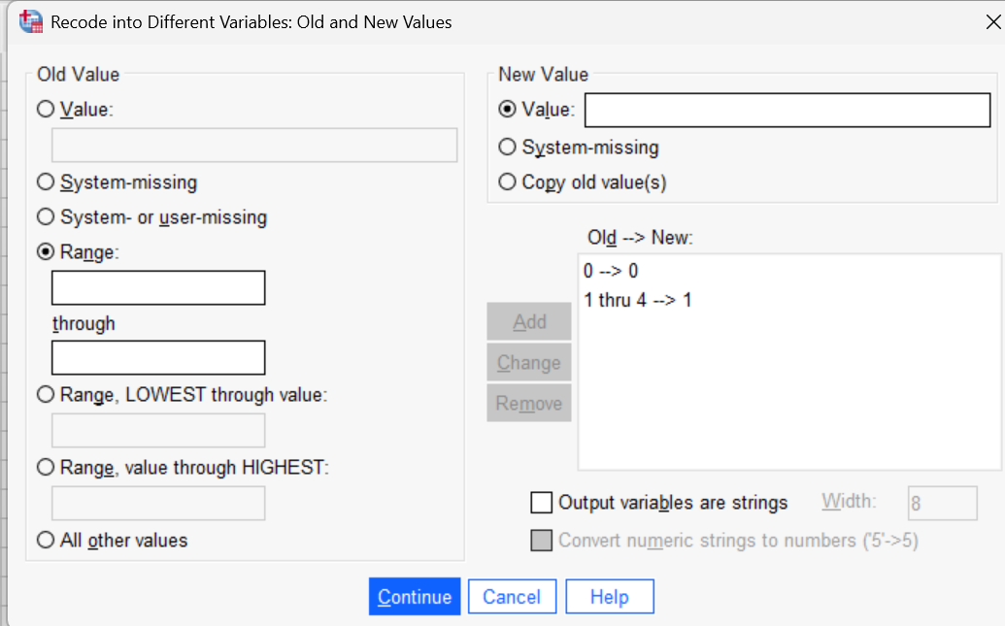
Figure 2. SPSS recoding dialog showing the mapping of original NUM values to the binary target.
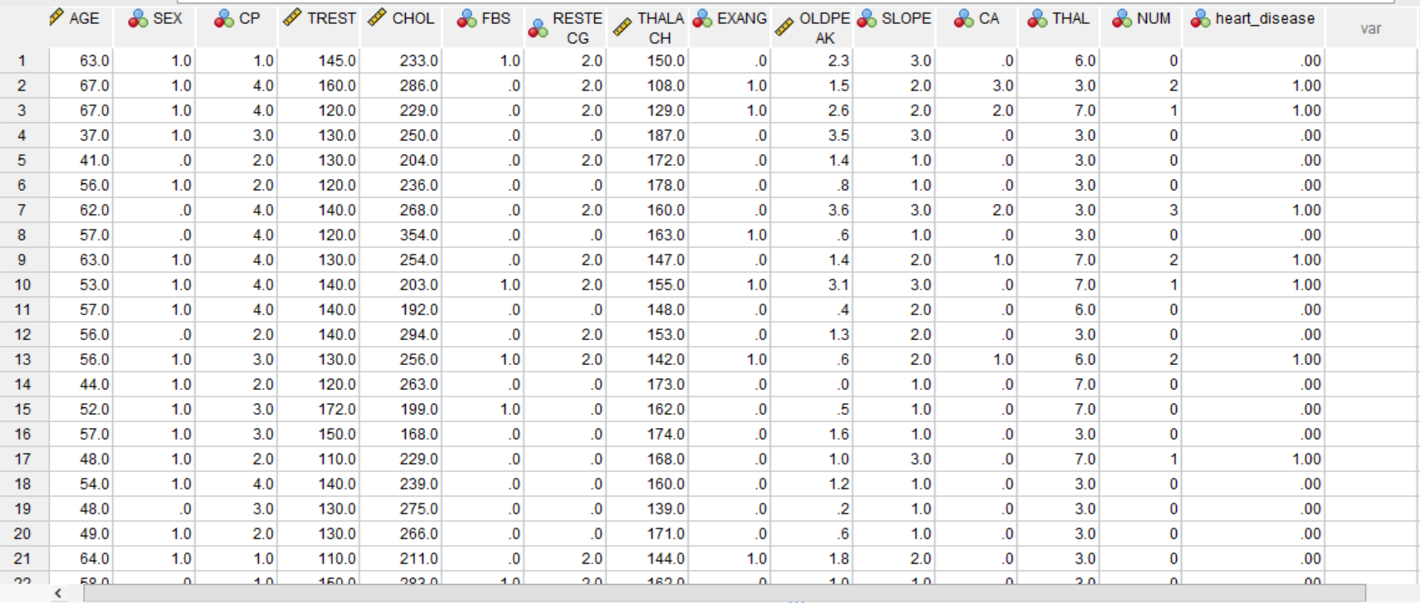
Figure 3. SPSS Data View showing the original NUM field and the newly created heart_disease field.

5. Missing-Value Analysis
The SPSS frequency output identified missing values in two coded variables. CA had 299 valid records and 4 system-missing records; THAL had 301 valid records and 2 system-missing records. This corresponds to 1.3% missing for CA and 0.7% missing for THAL. The missing values were not manually replaced in SPSS. The Python workflow applies the preprocessing configured in the supplied script, so missing-data treatment should be described separately for each software workflow.
Variable | Valid N | Missing N | Missing %
CA | 299 | 4 | 1.3%
THAL | 301 | 2 | 0.7%

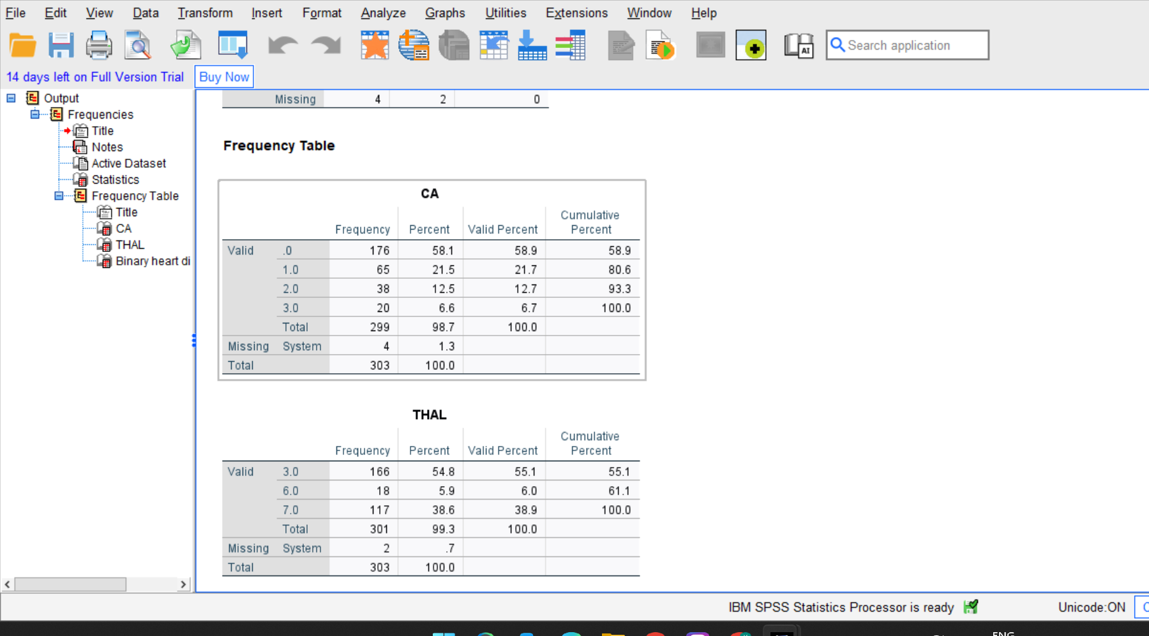
Figure 4. SPSS frequency output showing valid and missing values for CA and THAL.
Missing values matter because some statistical procedures exclude a record if one of the variables used in that procedure is missing. Therefore, the number of records used by an analysis can differ depending on the variables included and the missing-value method.

6. Descriptive Statistics
Variable | N | Minimum | Maximum | Mean | Std. Deviation
AGE | 303 | 29.0 | 77.0 | 54.439 | 9.0387
TREST | 303 | 94.0 | 200.0 | 131.690 | 17.5997
CHOL | 303 | 126.0 | 564.0 | 246.693 | 51.7769
THALACH | 303 | 71.0 | 202.0 | 149.607 | 22.8750
OLDPEAK | 303 | 0.0 | 6.2 | 1.040 | 1.1611
heart_disease | 303 | 0 | 1 | 0.4587 | 0.49912

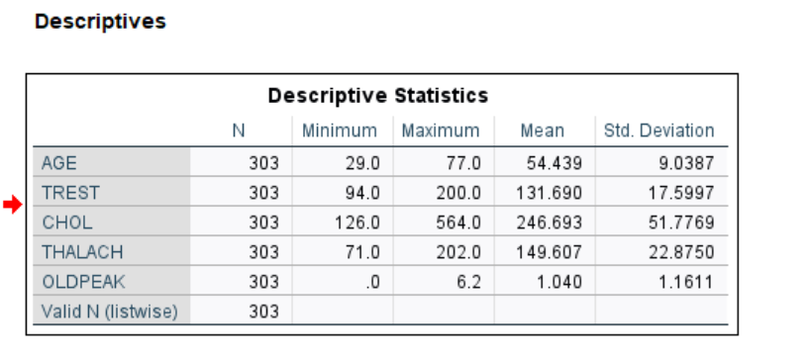
Figure 5. SPSS Descriptive Statistics output for the selected numeric variables.

6.1 Interpretation
- AGE: The mean age was 54.439 years, with a standard deviation of 9.0387. The records ranged from age 29 to 77.
- TREST: Mean resting blood pressure was 131.690, with a standard deviation of 17.5997 and a range from 94 to 200.
- CHOL: Mean cholesterol was 246.693, with a standard deviation of 51.7769 and a range from 126 to 564.
- THALACH: Mean maximum heart rate was 149.607, with a standard deviation of 22.8750 and a range from 71 to 202.
- OLDPEAK: The mean was 1.040, with a standard deviation of 1.1611 and a range from 0 to 6.2.
- heart_disease: The mean of 0.4587 indicates that approximately 45.87% of the records belong to the positive class. Exact class counts should be taken from the target frequency table.
The mean and standard deviation describe the distribution of values in this sample. They do not, by themselves, show that a variable causes heart disease or that a particular value is medically abnormal.

7. Exploratory Data Analysis (EDA)
The initial EDA included frequency analysis of coded categorical variables, checking missing values in CA and THAL, and calculating descriptive statistics for selected numeric variables. These steps help reveal the dataset's structure, value ranges, and data-quality issues before fitting models.

7.1 Exploratory Data Analysis Charts
- A bar chart of heart_disease to show the class distribution.
- Histograms of AGE and CHOL to inspect their distributions and possible extreme values.
- Boxplots of AGE, CHOL, THALACH, and OLDPEAK grouped by heart_disease to visually compare the two classes.
- Crosstabulations of selected categorical predictors against heart_disease.
The following charts were generated from the uploaded processed Cleveland dataset. The target was derived using NUM = 0 → heart_disease = 0 and NUM values 1–4 → heart_disease = 1. These are descriptive visualizations of this dataset, not clinical findings.
heart_disease value | Meaning | Frequency
0 | No recorded disease (NUM = 0) | 164
1 | Disease recorded (NUM = 1–4) | 139
Total | All records | 303

Target frequency table

Figure 7. Target class distribution.
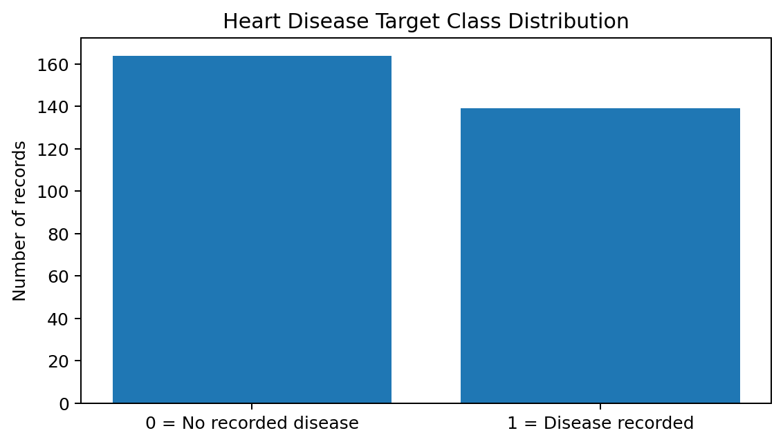
Figure 8. Age distribution.
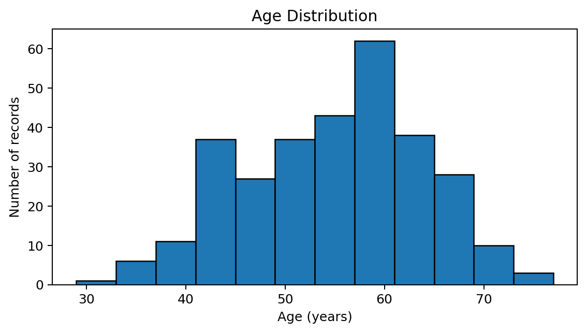
Figure 9. Cholesterol distribution.
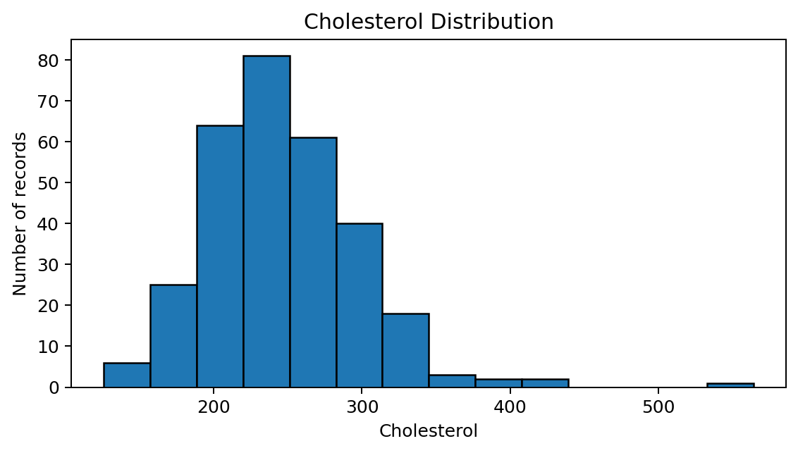
Figure 10. Age by recorded target class.
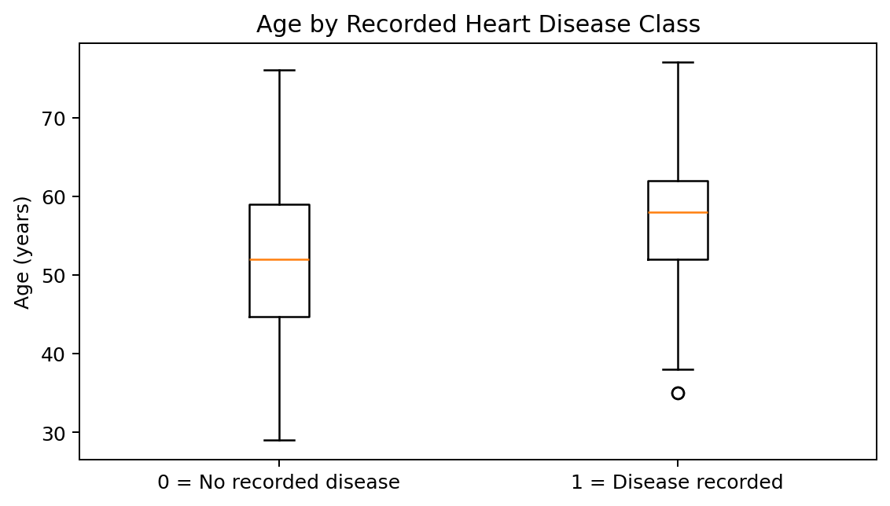
Figure 11. Cholesterol by recorded target class.
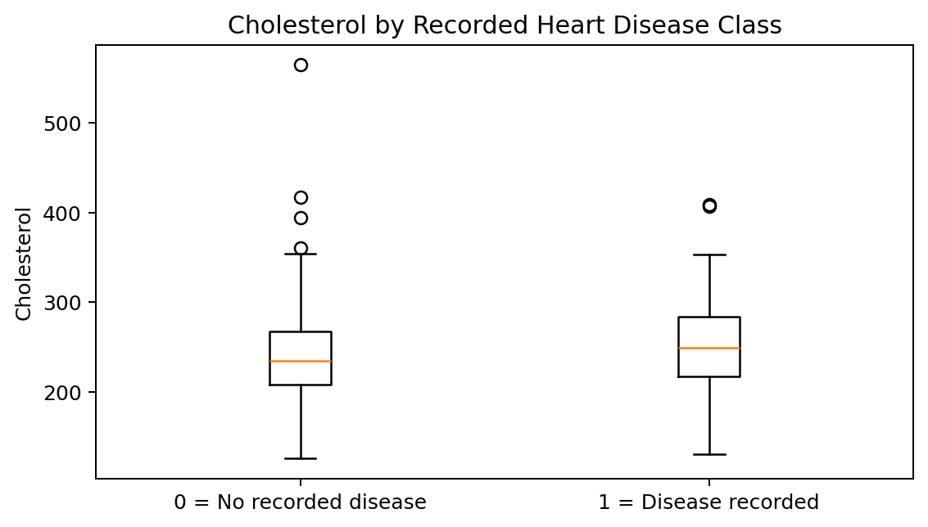

8. Modelling Methodology in Python
Two supervised classification algorithms were run: Logistic Regression and Decision Tree. The recorded run used 227 records for training and 76 records for testing. The training portion was used to fit each model, and the held-out test portion was used to calculate performance metrics. Using a separate test set provides an estimate of performance on unseen records from the same dataset, although results can vary with a different split.

8.1 Evaluation metrics
Metric | Meaning
Accuracy | Fraction of all test records classified correctly.
Precision | Among records predicted positive, the fraction that were truly positive.
Recall / Sensitivity | Among truly positive records, the fraction correctly identified.
Specificity | Among truly negative records, the fraction correctly identified.
F1-score | Harmonic mean of precision and recall.
ROC-AUC | Measures how well the model ranks positive cases above negative cases across classification thresholds.
Confusion matrix | Counts true negatives, false positives, false negatives, and true positives.

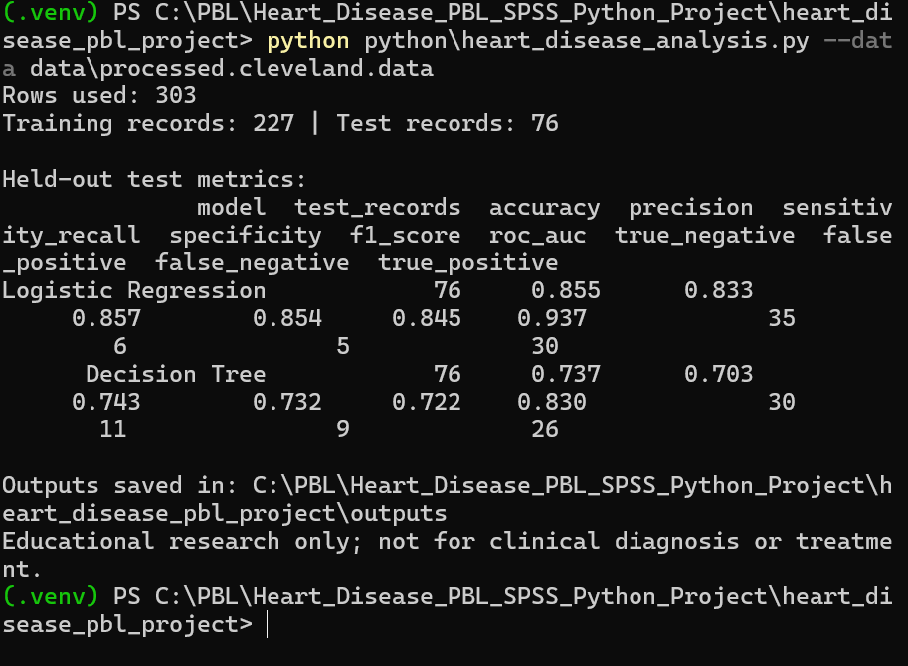
Figure 6. Python console output showing the model evaluation results from the recorded run.

9. Python Model Results
Metric | Logistic Regression | Decision Tree
Training records | 227 | 227
Test records | 76 | 76
Accuracy | 0.855 (85.5%) | 0.737 (73.7%)
Precision | 0.833 (83.3%) | 0.703 (70.3%)
Sensitivity / Recall | 0.857 (85.7%) | 0.743 (74.3%)
Specificity | 0.854 (85.4%) | 0.732 (73.2%)
F1-score | 0.845 (84.5%) | 0.722 (72.2%)
ROC-AUC | 0.937 | 0.830
True negatives (TN) | 35 | 30
False positives (FP) | 6 | 11
False negatives (FN) | 5 | 9
True positives (TP) | 30 | 26

9.1 Interpretation of model comparison
For the recorded test split, Logistic Regression performed better than the Decision Tree across all listed metrics. Its accuracy was 85.5%, compared with 73.7% for the Decision Tree. Its ROC-AUC was 0.937 compared with 0.830, indicating stronger ranking performance on this test set. Logistic Regression also produced fewer false positives (6 versus 11) and fewer false negatives (5 versus 9) in the displayed confusion counts. These findings are specific to this run and should not be interpreted as proof that the model is suitable for clinical use.
The test set contains 76 records. A small test set can make performance estimates uncertain, and a different train/test split may produce different values. Independent validation on a separate dataset would be needed before considering any real-world application.

10. SPSS and Python: Roles in the Project
Tool | Work completed / role
IBM SPSS Statistics | Data import, variable naming, binary target recoding, frequency tables for missing values, and descriptive statistics.
Python | Training and test split, Logistic Regression and Decision Tree modelling, metric calculation, and confusion-matrix evaluation.

The available screenshots document SPSS preparation and descriptive analysis, while the Python console screenshot documents the model metrics. A separate SPSS Binary Logistic Regression output has not been included in the evidence available for this report. Therefore, SPSS regression coefficients, odds ratios, p-values, and SPSS classification performance are not reported or fabricated here.

11. Discussion and Key Findings
- The dataset contains 303 records with 13 predictors and the original NUM target.
- The target variable was converted from a five-level coded outcome to a binary outcome for classification.
- SPSS detected 4 missing values in CA and 2 in THAL.
- The mean age in the dataset was approximately 54.4 years.
- Logistic Regression achieved 85.5% accuracy and ROC-AUC 0.937 on the recorded test split.
- The Decision Tree achieved 73.7% accuracy and ROC-AUC 0.830 on the same split.
- Within this experiment, Logistic Regression was the stronger of the two tested classifiers.

12. Limitations and Ethical Considerations
- The dataset has only 303 records and may not represent current or diverse populations.
- The outcome represents recorded status in the dataset; the project does not forecast future disease onset.
- Combining NUM values 1–4 into one class removes information about the original outcome levels.
- Model performance depends on the split, preprocessing, selected predictors, and model settings.
- Python held-out metrics should not be directly compared with results from a model fitted and evaluated on all available SPSS cases.
- The project is for education and coursework. It is not a diagnostic device, does not provide medical advice, and must not be used to make individual treatment or screening decisions.

13. Conclusion
This project demonstrated a complete introductory workflow spanning data preparation, descriptive analysis, and classification modelling. SPSS was used to import the dataset, define variables, create the binary target, inspect missing data, and summarize selected numeric variables. Python was used to train and evaluate Logistic Regression and Decision Tree models. In the recorded run, Logistic Regression performed better, with 85.5% accuracy and ROC-AUC of 0.937. Further work should include additional EDA charts, a documented SPSS Binary Logistic Regression analysis if required by the rubric, and validation on independent data.

14. References
Dua, D. and Graff, C. UCI Machine Learning Repository: Heart Disease Dataset. University of California, Irvine. Dataset used in this project: processed Cleveland subset.
IBM Corp. IBM SPSS Statistics documentation.
scikit-learn developers. scikit-learn documentation for Logistic Regression, Decision Trees, and classification metrics.

